User Manual

Jump In! SYSC 3110 Project

By: Jay McCracken 101066860

Purpose:

Creation of the Puzzle Game Jump In for the course SYSC 3110, being made for educational purposes.

**4 main milestone goals:**

* Basic game logic implemented in text-based format. Due October 18th (15%)
* GUI implementation of the game, and Unit tests. Due November 4th (20%)
* Add a solver and unlimited undo/redo. Integrate solver for hints. Due November 18th (30%)
* Add Save/Load feature, as well as a game level builder. Due December 2nd (35%)

**Basic Concept of the game:**

The object of the game is to move the rabbits and foxes around the game board until all the rabbits are safe in brown holes.

• Foxes move by sliding forward or backward. Foxes cannot jump over obstacles or be placed elsewhere on the board.

• Mushrooms are stationary and cannot be moved.

• Rabbits move by jumping horizontally or vertically over one or more spaces with obstacles: other rabbits, foxes, mushrooms or a combination of these:

    - Rabbits must land on the first empty space after a jump - they can never move over empty spaces.

    - Rabbits can never move without jumping over at least 1 obstacle, thus they can never move to an adjacent space.

    - A hole with a rabbit inside is an obstacle, while empty holes are not obstacles.

    - A rabbit can jump into – but not over – an empty hole.

    - If needed, rabbits can jump out of holes they are already sitting in.

    - Rabbits can jump over a fox no matter the orientation of the fox: tail to front, front to tail, or over the side.

How to Use:

The game is divided into parts the basics of the games changes depending on what milestone has been completed, see below how to use the milestones so far.

**Milestone 1:**

The game is currently set up as a text-based game. When the game loads in the it will all be within the console. The board will be created, Bunnies are represented by “Bun”, Foxes are represented by “Fox”, Mushrooms are represented by “Shr”, and holes are represented by “> <”, on each their tiles.

How to select a piece:

* To select a piece the game will prompt you to select a x coordinate of the piece you wish to grab and then the y coordinate of the piece.
* If you selected an empty spot or a mush room a console print out will say you are unable to select the piece, re prompt for new coordinates

How to move a piece

* To move a piece the game will prompt you to select a x coordinate of where you want to more, and then the y coordinate of where you want to move.
* If you are unable to move to a certain spot or the piece can not move like that, the console will out put that you are unable to and re prompt you.

How to move on to the next level

* The game will prompt you to say Y or N if you want to move on to the next level or not.

**Milestone 2:**

This is the current lay out of the game

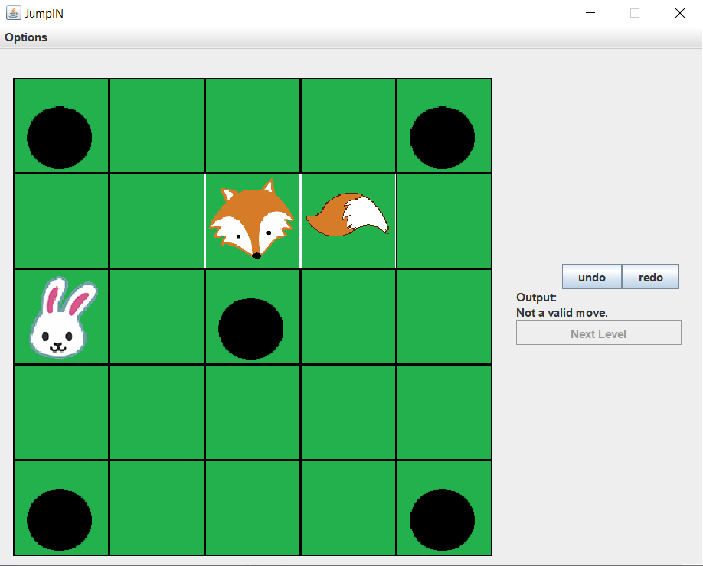

How to select a piece:

* You simply click on the tile that you with to move
* The program will highlight the piece in white (see fox in picture above)

How to move selected piece:

* Click on the tile you wish to move your selected piece too
* If it is not a valid move, under output it will say “Not a valid move.”

Other Buttons:

* Undo: goes back to before you moved a piece
* Redo: move the piece back to the place it was just undone from
* Next Level: moves the game on to the next level
  + Becomes available when current game is completed

Milestone 3:

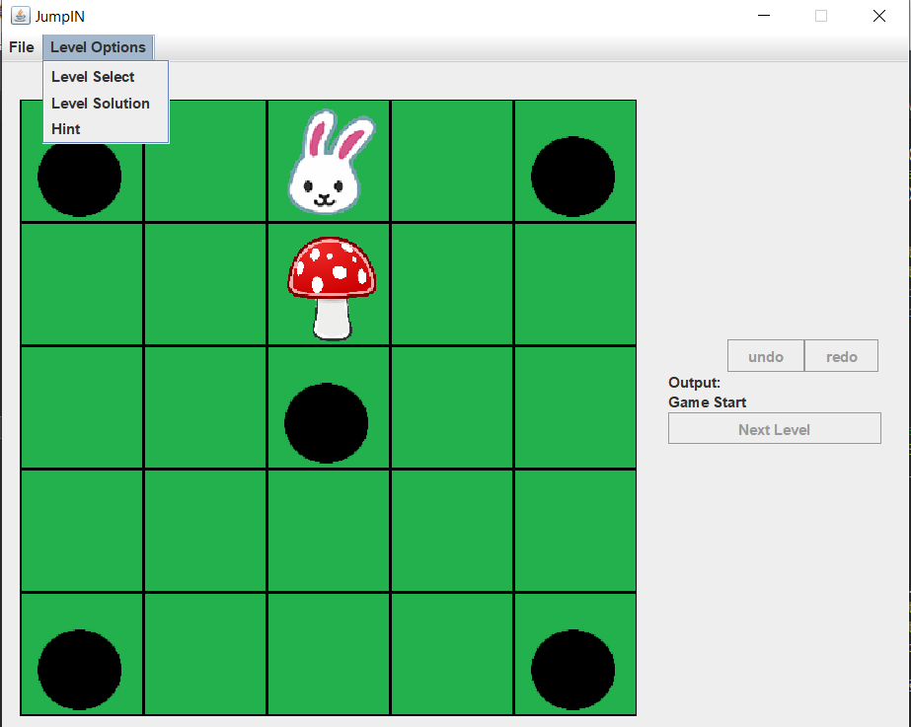

Level Solver:

* Within the menu under level options, the option Level Solver will bring up a pop up of the moves needed to win the puzzle.

Hint

* Clicking the hint option, will highlight the piece that needs to be moved in orange and the destination of the piece in purple.